SUMMER BBQ & QUIZ AT
THE CHERRY TREE, FAYGATE
SATURDAY 8TH AUGUST
FOOD FROM 7PM
QUIZ STARTS AT 8PM
TICKETS £10
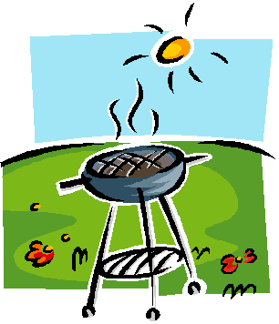
01293-851305
IN AID OF MOTOR NEURONE DISEASE
RAFFLE PRIZES TO BE WON!!

