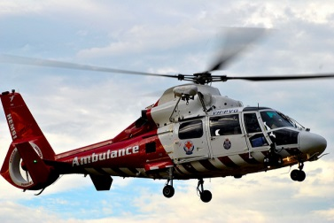

Cuppa & Chat
First Monday of each month
Monday 5 September & 3 October 2016
Any time between 10.30 – 12 in St Saviour’s Church, Colgate
Kent Surrey Sussex Air Ambulance Charity
Fundraising event
Join us on Monday 5 September as we raise funds for this worthwhile charity. The Kent Surrey Sussex Air Ambulance Charity are thrilled to hear that we have chosen them for our annual fundraising event so do join us to benefit this very worthwhile cause.

Like’ us on Facebook: Colgate and Faygate Cuppa and Chat
Check out local information and events on our web site: http://colgateandfaygate.community21.org

