**Horsham District - can you help us?**

**We have been listening to older people’s experiences, now we want to hear from anyone involved in an organisation or community group who:**

* provide transport to Horsham District residents getting to and from hospital?
* help District residents travel to or from hospital?
* support local people over 50 to live independently at home?
* help District residents when they come home from hospital?
* have knowledge or information of transport to hospital and related issues in your local area?

**We have been talking to residents of Horsham District who are over 50 about their experiences of going into and coming home from hospital in the last 12 months.**

**Now we want to talk to local organisations about their experiences supporting those residents, this additional insight is a vital part of the process.**

**4.00 – 6.00pm - 12 September 2017**

**Lavinia House, Dukes Square, Horsham RH12 1GZ**

***Working together with you we can make positive changes***

**To book your FREE place**

**call or email** [**info@ageukhorshamdistrict.org.uk**](mailto:info@ageukhorshamdistrict.org.uk)



[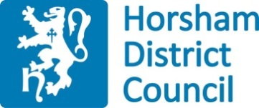](http://www.google.co.uk/url?sa=i&rct=j&q=&esrc=s&source=images&cd=&cad=rja&uact=8&ved=0ahUKEwiOuJyDzq7UAhXIvBQKHexECJAQjRwIBw&url=http://crawleymartialarts.co.uk/horsham-district-council/&psig=AFQjCNGUhKDEgtm20yXfuw7mVmOXD8LbQA&ust=1497023693804914)