Colgate Parish Council

The Council are pleased to announce that Automated External Defibrillator (AED) have been installed in Colgate (outside the village hall) and Faygate (outside the garage on Faygate Lane).A huge thank you to the Sussex Heart Charity (http://sussexheartcharity.org/) who donated the AEDs.The Sussex Heart Charity was formed in 1987 to support care of the heart throughout Sussex and work hard to raise the awareness of the effectiveness of the use of the AED and the improvement of survival of heart attack victims if a ADE is used in early treatment. In fact survival rates are as high as 70% when defibrillation pads are applied within 3 – 5 minutes of collapse.
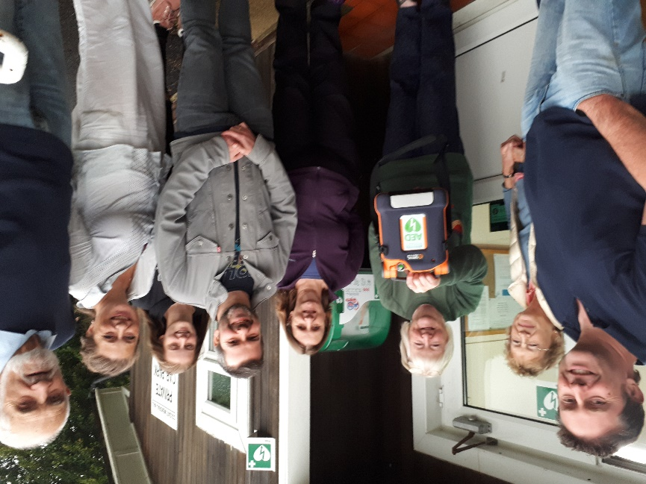

Photos show Councillors and residents celebrating the installation of the AED unit which can be used by all residents and visitors to the Parish. The ambulance service are aware of the location of the units.

The council will be taking responsibility to ensure the units are in good working order but should you have any concerns please report them immediately to the clerk.

Your Parish Council Needs You…….
Colgate Parish Council has a vacancy for one councillor.
Are you interested in what happens in your village? Would you like a say on how Colgate Parish Council is run? Councillors represent the electors in their parish ward. They are accessible to residents to listen to and deal with their concerns. Do you think you have what it takes?
Colgate Parish Council holds 10 council meetings per year as well as ad hoc planning meetings. As a councillor you will get involved in planning decisions as well as a variety of community issues.
All applications will be considered on 9th October at the Council Meeting. You will be asked to address the council for approximately 3 minutes to explain why you want to be a councillor and what you could bring to the post. If there are more than 1 applicant there will be a vote.
Please call the Parish Clerk on 01293 883944 or e mail colgateclerk@hotmail.co.uk for further information and an application form. Please apply before 30th September.

